Asia-China-Coin-3-Spade-Flat Handle--H 3.41 R2

400-300 BCE, 垣釿Yuan Jin (Jin of Yuan) Inscription Inverted FD291, H 3.41 R2, length 5.7CM/2.24Inches, width 3.1CM/1.22Inches. 垣釿桥足布."垣釿","Yuan Jin"Bridge-foot Spade-shape Coin."垣"place of Wei Nation. Now it is the Southwest of Qu Country, Shanxi Province."釿"JIN, Ancient metals weight, as well as currency. This one was made in the WEI Nation, while used in the 3 JIN and 2 Zhou area.

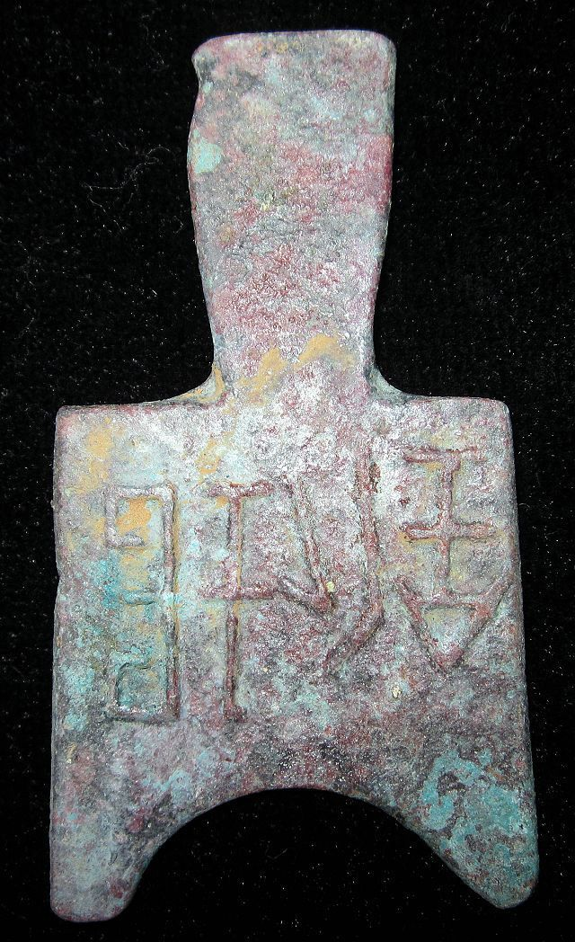

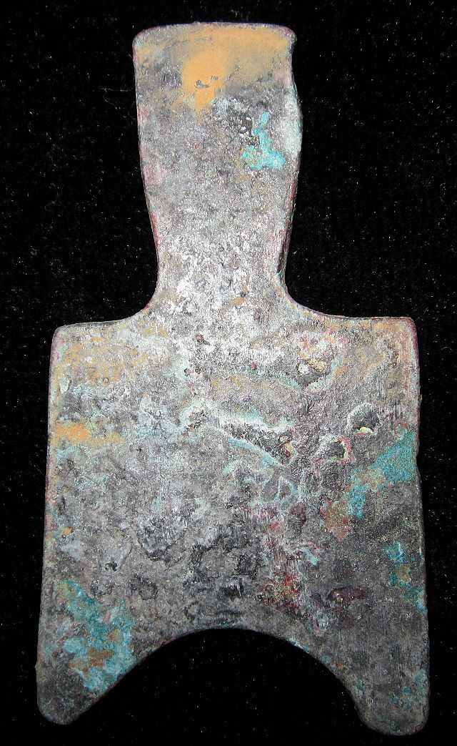

# VINTAGE WarringStatesPeriod CITY MINT CURRENCY MONEY BRONZE SPADESHAPE COIN垣釿桥足布

### Seller information

|  |  |
| --- | --- |
|  |  |

[bcculture](http://myworld.ebay.com/bcculture?_trksid=p2047675.l2559) ([84](http://feedback.ebay.com/ws/eBayISAPI.dll?ViewFeedback&userid=bcculture&iid=251416092743&ssPageName=VIP:feedback&ftab=FeedbackAsSeller&rt=nc&_trksid=p2047675.l2560) )

100% Positive feedback

[Follow this seller](http://www.ebay.com/itm/VINTAGE-WarringStatesPeriod-CITY-MINT-CURRENCY-MONEY-BRONZE-SPADESHAPE-COIN-/251416092743?_trksid=p2047675.l2557&ssPageName=STRK%3AMEWNX%3AIT&nma=true&si=5L4Tlo08dyY9pQflhUEb6fWvMTI%253D&orig_cvip=true&rt=nc)

[See other items](http://www.ebay.com/sch/bcculture/m.html?item=251416092743&nma=true&rt=nc&si=5L4Tlo08dyY9pQflhUEb6fWvMTI%253D&orig_cvip=true&ssPageName=STRK%3AMEWNX%3AIT&_trksid=p2047675.l2562)

Visit store:

[bcculture](http://stores.ebay.com/bcculture?_trksid=p2047675.l2563)

Top of Form

## Item Information

Item condition:

--not specified

“Rust on the body,Museum quality”

Ended:

Jan 08, 2014 21:21:10 PST

Winning bid:

US $78.00

[ [12 bids](http://offer.ebay.com/ws/eBayISAPI.dll?ViewBids&_trksid=p2047675.l2565&rt=nc&item=251416092743) ]

[Add to list](http://cgi1.ebay.com/ws/eBayISAPI.dll?MakeTrack&_trksid=p2047675.l1360&rt=nc&item=251416092743&sourcePage=4340&ssPageName=VIP:watchlink:top:en&SubmitAction.AddToListVI=x&wt=b839cb75e63a96c37ae455c3d3e46819)

|  |  |  |  |
| --- | --- | --- | --- |
|  | Join **eBay Bucks** and earn **%** back on this item. [See conditionsfor eBay Bucks - opens in a new window or tab](http://pages.ebay.com/rewards/terms.html?ssPageName=STRK:VI:LNLK:TCS) | | |
|  | | New customers get $10 back on 1st purchase Subject to credit approval.[See terms](https://apply.billmelater.com/apply?guid=F2W40R2E&assetId=NBRVI0114) |  |

Shipping:

$10.00 Economy Shipping from outside US | [See details](http://www.ebay.com/itm/VINTAGE-WarringStatesPeriod-CITY-MINT-CURRENCY-MONEY-BRONZE-SPADESHAPE-COIN-/251416092743?_trksid=p2047675.l2557&ssPageName=STRK%3AMEWNX%3AIT&nma=true&si=5L4Tlo08dyY9pQflhUEb6fWvMTI%253D&orig_cvip=true&rt=nc" \l "shpCntId)

See details about international shipping here.

Item location:

GuangZhou, China

Ships to:

Worldwide

Bottom of Form